**BANK LOAN REPORT QUERY DOCUMENT**

1. **BANK LOAN REPORT | SUMMARY**

**KPI’s:**

**Total Loan Applications**

SELECT

COUNT(id) AS Total_Applications

FROM

bank_loan_data;

-- #info: This query counts the total number of loan applications in the 'bank_loan_data' table by counting the 'id' field.



**MTD Loan Applications**

SELECT

COUNT(id) AS Total_Applications

FROM

bank_loan_data

WHERE

MONTH(issue_date) = 12;

-- #info: This query counts the total number of loan applications issued in December (month 12) in the 'bank_loan_data' table.



**PMTD Loan Applications**

SELECT

COUNT(id) AS Total_Applications

FROM

bank_loan_data

WHERE

MONTH(issue_date) = 11;

-- #info: This query counts the total number of loan applications issued in November (month 11) in the 'bank_loan_data' table.



**Total Funded Amount**

SELECT

SUM(loan_amount) AS Total_Funded_Amount

FROM

bank_loan_data;

-- #info: This query calculates the total sum of all loan amounts in the 'bank_loan_data' table.



**MTD Total Funded Amount**

SELECT

SUM(loan_amount) AS Total_Funded_Amount

FROM

bank_loan_data

WHERE

MONTH(issue_date) = 12;

-- #info: This query calculates the total sum of loan amounts funded in December (month 12) from the 'bank_loan_data' table.



**PMTD Total Funded Amount**

SELECT

SUM(loan_amount) AS Total_Funded_Amount -- #info: Calculate total loan amounts

FROM

bank_loan_data -- #info: From the bank loan data table

WHERE

MONTH(issue_date) = 11; -- #info: Filter for loans issued in November



**Total Amount Received**

SELECT

SUM(total_payment) AS Total_Amount_Collected -- #info: Calculate total payments collected

FROM

bank_loan_data; -- #info: From the bank loan data table



**MTD Total Amount Received**

SELECT

SUM(total_payment) AS Total_Amount_Collected -- #info: Calculate total payments collected

FROM

bank_loan_data -- #info: From the bank loan data table

WHERE

MONTH(issue_date) = 12; -- #info: Filter for payments collected in December



**PMTD Total Amount Received**

SELECT

SUM(total_payment) AS Total_Amount_Collected -- #info: Calculate total payments collected

FROM

bank_loan_data -- #info: From the bank loan data table

WHERE

MONTH(issue_date) = 11; -- #info: Filter for payments collected in November



**Average Interest Rate**

SELECT

AVG(int_rate) * 100 AS Avg_Int_Rate -- #info: Calculate average interest rate in percentage

FROM

bank_loan_data; -- #info: From the bank loan data table



**MTD Average Interest**

SELECT

AVG(int_rate) * 100 AS MTD_Avg_Int_Rate -- Calculate average interest rate in percentage

FROM

bank_loan_data -- Specify the data source

WHERE

MONTH(issue_date) = 12; -- Filter for loans issued in December



**PMTD Average Interest**

SELECT

AVG(int_rate) * 100 AS PMTD_Avg_Int_Rate -- Calculate average interest rate in percentage

FROM

bank_loan_data -- Specify the data source

WHERE

MONTH(issue_date) = 11; -- Filter for loans issued in November



**Avg DTI**

SELECT

AVG(dti) * 100 AS Avg_DTI -- Calculate average debt-to-income ratio in percentage

FROM

bank_loan_data -- Specify the data source



**MTD Avg DTI**

SELECT

AVG(dti) * 100 AS MTD_Avg_DTI -- Calculate average debt-to-income ratio in percentage

FROM

bank_loan_data -- Specify the data source

WHERE

MONTH(issue_date) = 12; -- Filter for loans issued in December



**PMTD Avg DTI**

SELECT

AVG(dti) * 100 AS PMTD_Avg_DTI -- Calculate average debt-to-income ratio in percentage

FROM

bank_loan_data -- Specify the data source

WHERE

MONTH(issue_date) = 11; -- Filter for loans issued in November



**GOOD LOAN ISSUED**

**Good Loan Percentage**

SELECT

(COUNT(CASE WHEN loan_status = 'Fully Paid' OR loan_status = 'Current' THEN id END) * 100.0) / -- Calculate percentage of good loans

COUNT(id) AS Good_Loan_Percentage -- Total number of loans

FROM

bank_loan_data -- Specify the data source



**Good Loan Applications**

SELECT

COUNT(id) AS Good_Loan_Applications -- Count of loan applications with 'Fully Paid' or 'Current' status

FROM

bank_loan_data -- Specify the data source

WHERE

loan_status = 'Fully Paid' OR loan_status = 'Current'; -- Filter for good loan statuses



**Good Loan Funded Amount**

SELECT

SUM(loan_amount) AS Good_Loan_Funded_amount -- Sum of loan amounts for good loans

FROM

bank_loan_data -- Specify the data source

WHERE

loan_status = 'Fully Paid' OR loan_status = 'Current'; -- Filter for good loan statuses



**Good Loan Amount Received**

SELECT

SUM(total_payment) AS Good_Loan_amount_received -- Sum of total payments received for good loans

FROM

bank_loan_data -- Specify the data source

WHERE

loan_status = 'Fully Paid' OR loan_status = 'Current'; -- Filter for good loan statuses



**BAD LOAN ISSUED**

**Bad Loan Percentage**

SELECT

(COUNT(CASE WHEN loan_status = 'Charged Off' THEN id END) * 100.0) / -- Calculate percentage of bad loans

COUNT(id) AS Bad_Loan_Percentage -- Total number of loans

FROM

bank_loan_data -- Specify the data source



**Bad Loan Applications**

SELECT

COUNT(id) AS Bad_Loan_Applications -- Count of loan applications with 'Charged Off' status

FROM

bank_loan_data -- Specify the data source

WHERE

loan_status = 'Charged Off'; -- Filter for bad loan status



**Bad Loan Funded Amount**

SELECT

SUM(loan_amount) AS Bad_Loan_Funded_amount -- Sum of loan amounts for bad loans

FROM

bank_loan_data -- Specify the data source

WHERE

loan_status = 'Charged Off'; -- Filter for bad loan status



**Bad Loan Amount Received**

SELECT

SUM(total_payment) AS Bad_Loan_amount_received -- Sum of total payments received for bad loans

FROM

bank_loan_data -- Specify the data source

WHERE

loan_status = 'Charged Off'; -- Filter for bad loan status



**LOAN STATUS**

SELECT

loan_status, -- Group results by loan status

COUNT(id) AS LoanCount, -- Count of loans for each status

SUM(total_payment) AS Total_Amount_Received, -- Total payments received for each status

SUM(loan_amount) AS Total_Funded_Amount, -- Total loan amounts funded for each status

AVG(int_rate * 100) AS Interest_Rate, -- Average interest rate in percentage for each status

AVG(dti * 100) AS DTI -- Average debt-to-income ratio in percentage for each status

FROM

bank_loan_data -- Specify the data source

GROUP BY

loan_status; -- Group the results by loan status

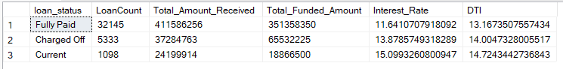

SELECT

loan_status, -- Group results by loan status

SUM(total_payment) AS MTD_Total_Amount_Received, -- Total payments received in December for each status

SUM(loan_amount) AS MTD_Total_Funded_Amount -- Total loan amounts funded in December for each status

FROM

bank_loan_data -- Specify the data source

WHERE

MONTH(issue_date) = 12 -- Filter for loans issued in December

GROUP BY

loan_status; -- Group the results by loan status

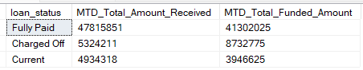

1. **BANK LOAN REPORT | OVERVIEW**

**MONTH**

SELECT

MONTH(issue_date) AS Month_Number, -- Extract month number from issue_date

DATENAME(MONTH, issue_date) AS Month_name, -- Get the name of the month from issue_date

COUNT(id) AS Total_Loan_Applications, -- Count of loan applications per month

SUM(loan_amount) AS Total_Funded_Amount, -- Total loan amounts funded per month

SUM(total_payment) AS Total_Amount_Received -- Total payments received per month

FROM

bank_loan_data -- Specify the data source

GROUP BY

MONTH(issue_date), DATENAME(MONTH, issue_date) -- Group results by month number and month name

ORDER BY

MONTH(issue_date); -- Order results by month number

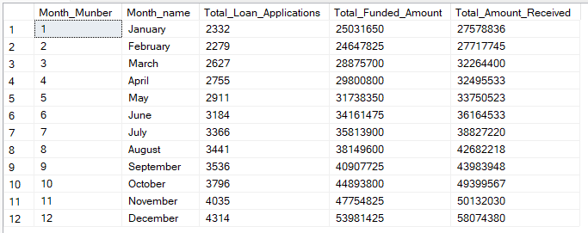

**STATE**

SELECT

address_state AS State, -- Group results by state

COUNT(id) AS Total_Loan_Applications, -- Count of loan applications per state

SUM(loan_amount) AS Total_Funded_Amount, -- Total loan amounts funded per state

SUM(total_payment) AS Total_Amount_Received -- Total payments received per state

FROM

bank_loan_data -- Specify the data source

GROUP BY

address_state -- Group results by address state

ORDER BY

address_state; -- Order results by address state

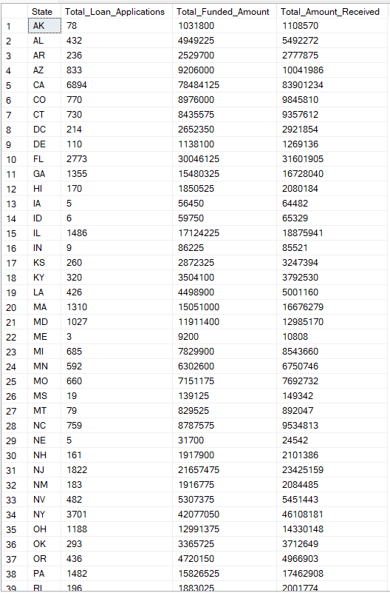

**TERM**

SELECT

term AS Term, -- Group results by loan term

COUNT(id) AS Total_Loan_Applications, -- Count of loan applications per term

SUM(loan_amount) AS Total_Funded_Amount, -- Total loan amounts funded per term

SUM(total_payment) AS Total_Amount_Received -- Total payments received per term

FROM

bank_loan_data -- Specify the data source

GROUP BY

term -- Group results by term

ORDER BY

term; -- Order results by term

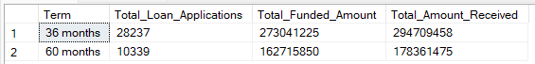

**EMPLOYEE LENGTH**

SELECT

emp_length AS Employee_Length, -- Group results by employee length

COUNT(id) AS Total_Loan_Applications, -- Count of loan applications per employee length

SUM(loan_amount) AS Total_Funded_Amount, -- Total loan amounts funded per employee length

SUM(total_payment) AS Total_Amount_Received -- Total payments received per employee length

FROM

bank_loan_data -- Specify the data source

GROUP BY

emp_length -- Group results by employee length

ORDER BY

emp_length; -- Order results by employee length

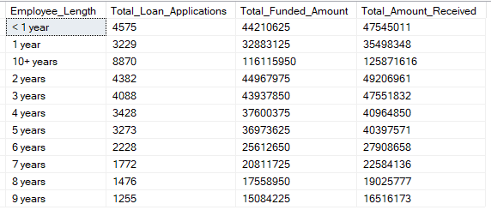

**PURPOSE**

SELECT

purpose AS PURPOSE, -- Group results by loan purpose

COUNT(id) AS Total_Loan_Applications, -- Count of loan applications per purpose

SUM(loan_amount) AS Total_Funded_Amount, -- Total loan amounts funded per purpose

SUM(total_payment) AS Total_Amount_Received -- Total payments received per purpose

FROM

bank_loan_data -- Specify the data source

GROUP BY

purpose -- Group results by loan purpose

ORDER BY

purpose; -- Order results by loan purpose

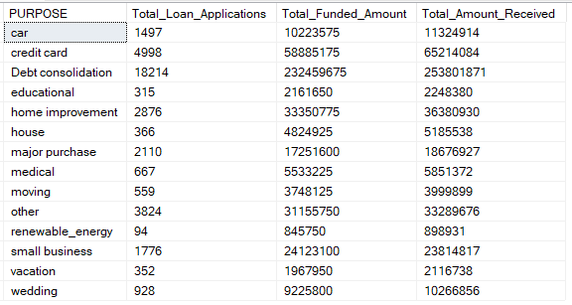

**HOME OWNERSHIP**

SELECT

home_ownership AS Home_Ownership, -- Group results by home ownership status

COUNT(id) AS Total_Loan_Applications, -- Count of loan applications per home ownership status

SUM(loan_amount) AS Total_Funded_Amount, -- Total loan amounts funded per home ownership status

SUM(total_payment) AS Total_Amount_Received -- Total payments received per home ownership status

FROM

bank_loan_data -- Specify the data source

GROUP BY

home_ownership -- Group results by home ownership status

ORDER BY

home_ownership; -- Order results by home ownership status

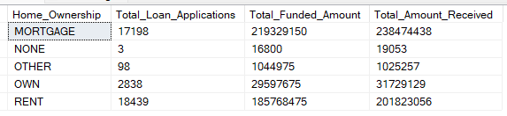

*See the results when we hit the Grade A in the filters for dashboards.*

SELECT

purpose AS PURPOSE, -- Group results by loan purpose

COUNT(id) AS Total_Loan_Applications, -- Count of loan applications per purpose

SUM(loan_amount) AS Total_Funded_Amount, -- Total loan amounts funded per purpose

SUM(total_payment) AS Total_Amount_Received -- Total payments received per purpose

FROM

bank_loan_data -- Specify the data source

WHERE

grade = 'A' -- Filter for loans with grade 'A'

GROUP BY

purpose -- Group results by loan purpose

ORDER BY

purpose; -- Order results by loan purpose